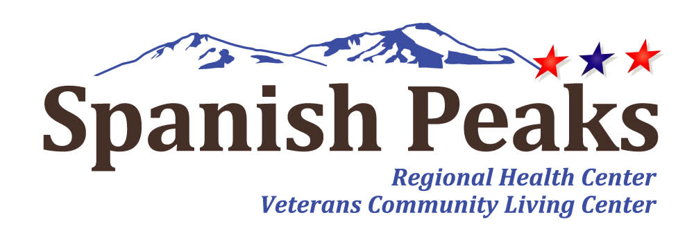

Spanish Peaks Regional Health Center-Huerfano County Hospital District
Regular Board Meeting
*Notice of Agenda*

Spanish Peaks Regional Health Center
February 27, 2025, at 12:00 PM MDT to February 27, 2025 at 3:00 PM MDT
23500 US HWY 160 Walsenburg, CO 81089

Microsoft Teams
Join the meeting now
Meeting ID: 255 081 222 630
Passcode: kn2Cy63Z
Dial in by phone
+1 929-352-2641,,156902580# United States, New York City
Find a local number
Phone conference ID: 156 902 580#

Agenda
- Call to Order, Pledge of Allegiance, & Roll Call
Jill Davis Homerding
- Recognition of Visitors
Jill Davis Homerding
- Minute Approval
Jill Davis Homerding
*Action Item – January 23, 2025 - Regular Board Meeting
- State Observers Report
Janet Hutchinson
- CEO Report
Kay Whitley
- NHA Report
Teresa Clift
- CMO Report
Dr. Vijan
- CNO Report
Katy Frazier
- Financial Report
Lola Spradley
- CFO Report
Brenda Parnell
- Legislative Committee Update
Lola Spradley
- SPHC Foundation Report
John Davis
- Old Business
New discussion on open topics
- Community Open Forum

**Before opening our Community Open Forum, please be aware of several requirements that we expect to be followed. First and foremost, this is an opportunity to present your ideas and/or concerns as long as civility is maintained. This will be a respectful session. You will be held to a time limit of 5 minutes. Only one speaker may approach at a time. Also, if requests are made or questions are asked, the Board is under no obligation to respond. This is not a conversation, but rather a place for you to be heard. Thank you.
- Executive Session
C.R.S. – 24.6-402(4)(g) – consideration of any documents protected by the mandatory nondisclosure provisions of the Open Records Act. Includes: medical records, personnel files, privileged documents (24-72-204(3)(a).
- Adjournment
- Next Meeting
March 27, 2025

