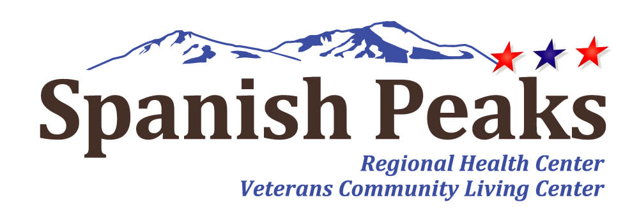

Spanish Peaks Regional Health Center-Huerfano County Hospital District
Special Board Meeting
*Notice of Agenda*

Spanish Peaks Regional Health Center
October 10, 2024 at 2:00 PM MDT to October 10, 2024 at 3:00 PM MDT
23500 US HWY 160 Walsenburg, CO 81089

Microsoft Teams Need help?
Join the meeting now
Meeting ID: 238 584 951 29
Passcode: Tbcb6f
Dial in by phone
+1 929-352-2641,,544403342# United States, New York City
Find a local number
Phone conference ID: 544 403 342#

- Call to Order, Pledge of Allegiance, and Roll Call
Jill Davis Homerding
- Review of 2025 Preliminary Budget
- Adjournment

